Lab- Identity, Access, and User Lifecycle Administration
Scenario: Meridian Community Health is a regulated organization with office staff, finance staff, and support personnel. The help desk is responsible for user onboarding, account administration, workstation logon support, file-share access, and basic access-review evidence for internal policy checks. In this lab I will build a small Windows domain, join a Windows 10 endpoint, create department-based access controls, onboard a user, resolve a locked account, and offboard a terminated user.

Lab Scope and Objectives:
- Build a small Active Directory domain on Windows Server 2022 with DNS and file services.

- Join a Windows 10 client to the domain and verify name resolution and domain logon.

- Create an OU structure, user naming standard, and security groups that support least privilege.

- Create department-based file shares and validate both successful and denied access from the client.

- Complete one new-hire onboarding workflow, one locked-account incident, and one offboarding workflow. Generate simple audit evidence with PowerShell
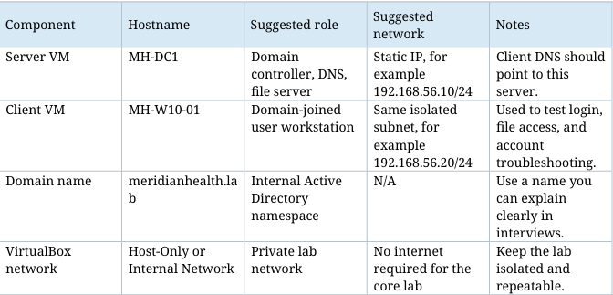

What I did:

Phase 1 - Build the Domain Foundation
- Rename both machines so the server and client names look intentional in screenshots.
- Configure the server with a static IP address. In a private lab, the default gateway may be blank if you do not need internet access.
- Install AD DS and DNS on the server, then promote the server to a new forest named meridianhealth.lab.
- After the reboot, confirm the server can resolve the domain and that DNS points to itself.
- Configure the Windows 10 client so its preferred DNS server is the IP address of MH-DC1.
- Join the client to the domain and verify that you can log on with a domain user account
Phase 2 - Design Identity and Access
- Created a simple, explainable structure. The goal is not to build a giant enterprise. The goal is to show that you understand organization, least privilege, and repeatable administration.
- Created OUs such as: Users, Workstations, Servers, Security Groups, and Disabled Users. Inside Users, create department OUs such as Operations, HR, and Finance.
- Created at least these security groups: SG_AllStaff_Read, SG_Operations_RW, SG_HR_RW, and SG_Finance_RW.
- Documented a naming convention for usernames and groups. Example: first initial + last name for usernames and SG_Department_AccessLevel for security groups.
- Created sample users for each department so your screenshots and exports show more than a single account.
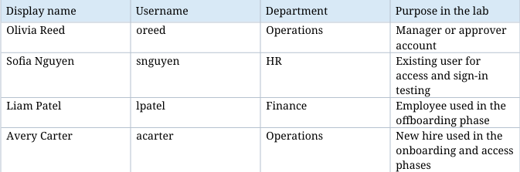
Phase 3 - Configure Shares, Permissions, and Policy
- Created shared folders such as C:\Shares\Public, C:\Shares\Operations, C:\Shares\HR, and C: \Shares\Finance.
- Granted access with security groups instead of assigning permissions directly to individual users.
- Gave SG_AllStaff_Read read access to Public. Gave each department group modify access to its own folder. Kept unauthorized users out of other department folders.
- Configured the domain account lockout threshold through the Group Policy editor so i could simulate and resolve a locked account. 5 invalid attempts with a 15-minute lockout duration.
Phase 4 - Complete a New-Hire Onboarding Ticket
Used Avery Carter as the new employee
- Created the user account in the correct department OU.
- Assigned a temporary password and required a password change at next logon.
- Added Avery to SG_AllStaff_Read and added Avery to Operations OU and SG_Operations_RW
- Documented the onboarding request in a ticket note that includes requester, requested access, business justification, and completion status.
- Signed in from the Windows 10 client as Avery and verified successful domain logon.
- Verified that Avery can access Public and Operations,but not HR, or Finance until the proper group membership is assigned
Phase 5 - Resolve a Locked Account Incident
- From the Windows 10 client, I intentionally entered the wrong password enough times to trigger the account lockout policy.
- I confirmed that the account was locked, then unlocked and reset the password from ADUC.
- I logged on successfully after the reset and documented the verification step in the ticket.
Phase 6 - Offboard a User and Produce Audit Evidence
- Used Liam Patel as the terminated employee.
- Disabled Liam Patel's account instead of deleting it immediately.
- Reset the password, removed group memberships that are no longer needed, and moved the account into the Disabled Users OU.
- Ran at least one PowerShell export that showed enabled/disabled status and one export that showed group membership.
Phase 7 - Simulated tickets and communications after each ticket

